**OVERVIEW**

**Coin sound: https://opengameart.org/content/plingy-coin**

**Car: https://opengameart.org/content/lap-rusher-assets**

**background: https://opengameart.org/content/2d-top-down-highway-background**

**Coin image: https://opengameart.org/content/coin-icon**

**Car Crash: https://opengameart.org/content/stop**

“Road Racer” is a basic 2D arcade game where the player(racer) tries to avoid the incoming cars

and get as many coins.

The Game’s premise: the game consists of a car which appears near the bottom of the gameplay

screen with a background image of a Highway. The user can move the car to the left and right using

the corresponding arrow keys. A series of coins and incoming cars fall from the top of the screen.

Each coin will fall from a different x position, with different speeds between 3 and 6 pixels per frame

straight down, while for the cars(obstacle) moves with a different speed between 6 and 12 pixels

per frame straight down.If the car(player) touches a coin, a positive sound effect is played, while if

the car(player) collides with the incoming car(obstacle), a crash sound effect is played. If a coin or

car(obstacle) leaves the bottom of the screen, it is reset to a new random position at the top of the

Screen with a new falling speed.

**THE GAME CLASS**

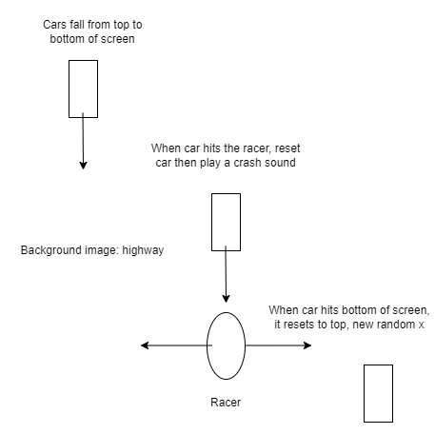

**Algorithm**

Import pygame, simpleGE and random

Create a class named game

Define __init__

Set the background to a highway

Create the car crash sound

Create a sprite called racer

Create a sprite list

Create the obstacles

Define process

Check if any of the obstacles collide with the racer

If they do

Play the crash sound and reset the obstacle

Subtract 5 points after collision

Check if any of the coins collide with the racer

If they do

Play the coin sound and reset the coin

Add 20 points after collision

Check if time left is < 0

If time left is < 0

Print the score(the points)

Stop game

Check if the racer is still on the highway

If it is off the highway, put it 10 pixels back onto the highway

Create a class named racer

Define __init__

Set the racer image to be a car

Define the size, movement speed, position and angle

Define process

If the left arrow is pressed, move the car left by its movement speed

If the right arrow is pressed, move the car right by its movement speed

Create a class named obstacles

Define __init__

Set the obstacle image to be a car

Define the size, max and min movement speeds, and angle

Give them their starting positions

Set dy equal to a random number between the max and min speed

Define reset

Reset the obstacle up to the top of the screen with a random x location on the road

Give it a random movement speed between its max and min speeds

Define checkbounds

Check if the obstacle is at the bottom of the screen and if it is, reset it

Create a class named Coin

Define __init__

Set the image to be a coin

Define the size, movement speed, position and angle

Define reset

Reset the coin up to the top of the screen with a random x location on the road

Give it a random movement speed between its max and min speeds

Define checkbounds

Check if the coin is at the bottom of the screen and if it is, reset it

Create a class for the Time Label

Define __init__

Set the time text

Set the location of the label

Create a class for the score label

Define __init__

Set the score text

Set the location of the label

Create an instructions class

Define __init__

Set the previous score

Set the background

Create a multiple line label with instructions

Set the location of this label

Create and give the location to the play button

Create and give the location to the quit button

Create a last score label showing the previous score

Add all labels and buttons to the sprite list

Define process function

If play button is clicked

Set the response to equal play and stop the current action

if quit button is clicked

Set the response to equal play and stop the current action

Define main function

Set keep going to true

Set last score to zero

While keep going

Run the instruction screen

If the response is play

Run the game

Else

Set keep going false